Randall Campbell & Kalyana S Nanduri

health insurance market place

Business Understanding
The Health Insurance industry underwrites (i.e. assumes the risks of and assigns premiums for) health and medical insurance policies. Insurance is the transfer of the risk of a loss in exchange for payment. Operators also provide administrative services for self-funded insurance plans (whereby an employer provides health benefits to workers with its own funds).
The Health and Medical Insurance industry, which/THAT is made up of carriers of private, group and public health, medical, dental insurance, was characterized by slow growth five years ago as a result of reduced employer coverage and continued consumer deleveraging. However, consistent increases in healthcare expenditure and medical cost inflation, as well as a sharp decline in the uninsured rate, have driven industry growth in recent years.
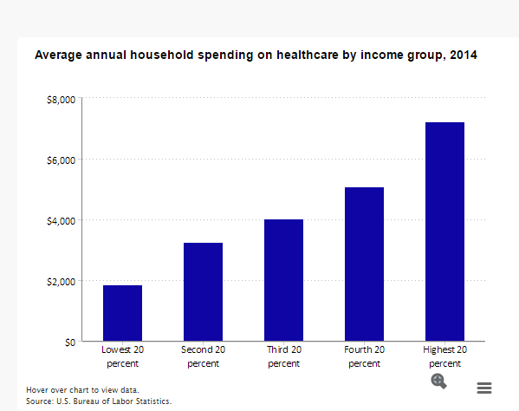
Exhibit(a) Bls.gov bar chart displaying average household spending on healthcare
Most industry revenue is generated from premiums that are related to fully funded insurance policies. Under this traditional coverage, the health insurer is financially responsible for paying all the incurred coverage benefits and administration costs of healthcare benefits. In return, the company receives a premium. Health insurers also generate income by providing network-based health and well-being services to beneficiaries in government-sponsored healthcare programs such as Medicare and Medicaid.
The U.S. insurance industry’s net premiums written totaled $1.2 trillion in 2015, with premiums recorded by life/health (L/H) insurers accounting for 55 percent and premiums by property/casualty (P/C) insurers accounting for 45 percent, as per S&P Global Market Intelligence.
Due to the Affordable Care Act enacted by President Barack Obama on March 23, 2010, Employers find themselves covering a higher percentage of their employee’s health insurance cost than in previous years. Despite incentives, such as tax breaks and tax credits, offered to small businesses via the Small Business Health Options Program (SHOP), many employers still find the mandate to be a financial burden. So much of a burden that many businesses, large and small, have laid off or repurposed employees, reduced employee hours (full-time to part-time), or relocated operations to states or even other countries to offset the cost incurred due to the health insurance mandate.
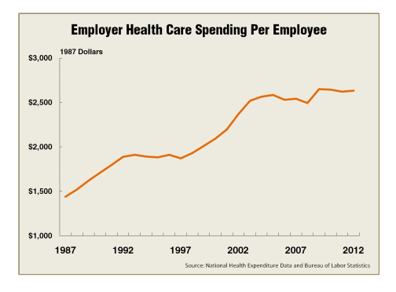
Exhibit(b) Bls.gov graph displaying the increase in Employee Health Care spending from 1987 to 2012
MISSING INVESTIGATIVE QUESTIONS? 27/30: SHOULD BE STATED UPFRONT HERE
Data Understanding - Data Set
Our Data Set was extracted from https://www.kaggle.com/hhs/health-insurance-marketplace
The Health Insurance Marketplace Public Use Files contain data on health and dental plans offered to individuals and small businesses through the US Health Insurance Marketplace.
This data was originally prepared and released by the Centers for Medicare & Medicaid Services (CMS). This processed version has three components:

Combined CSV files that contain across 2014 - 2016:
- BusinessRules.csv (BR) - This CSV file describes the variables contained in the Business Rules. Each record relates to a set of rules for the application of rates for one plan. The BR contains plan-level data on the application of rates, such as allowed relationships (e.g., spouse, dependents) and tobacco use.
- Network.csv - The Network CSV contains issuer-level data identifying provider network URLs.
- PlanAttributes.csv - The Plan attributes contains plan-level data on maximum out of pocket payments, deductibles, cost sharing, health savings account (HSA) eligibility, formulary ID, and other plan attributes.
- Rate.csv - The Rate CSV file contains plan-level data on individual rates based on an eligible subscriber’s age, tobacco use, and geographic location.
Initially we started to use different csv's and merge them together. But after extensive time taking runs of the model, we used the datbase.sqlite file granted in the original file. We have created an r script that allows us to extract and transform the data as we see fit, and more importantly extract samples for modeling.
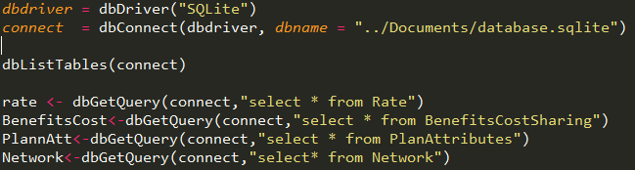
Once each dataset was extracted, the fields necessary for modeling were selected.
Businessyear and statecode served as the keys in the process of combining the selected fields into one dataframe.
After the merger, duplicates and files NA were removed until only complete cases remained. Then the sample was exported as a .csv file for later modeling in SPSS Modeler.
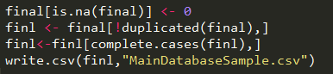
K with +25 R=65pts
Data Preparation - Cleaned Metrics - Clean/Transform/Select data
- All the Blanks were deleted/modified per the field requirement as stated in the data dictionary granted by The Center for Consumer Information and Insurance Oversight.
Data Dictionary terms and definitions for our selected variables below:
Variable Name | Definition | Data Type | Variable Label | Allowable Values
Business Year | Year for which plan provides coverage to enrollees | Text | Business Year | 2014-2015
State Code | Two-character state abbreviation indicating the state where the plan is offered | Text | State Code | All 50 state abbreviations + 9 territory abbreviations
Age | Categorical indicator of whether a subscriber's age is used to determine rate eligibility for the insurance plan | Text | Age | Family Option 0-65 and over
Individual Rate | Dollar value for the insurance premium cost applicable to a non-tobacco user for the insurance plan in a rating area, or to a general subscriber if there is no tobacco preference | Text | Individual Rate | Free Text
Benefits | Count of all the benefits a person is eligible | Text | Benefits | Number
Is covered | Categorical indicator of whether benefit is covered by the insurance plan | Flag | Is this Benefit Covered? | Covered  Not Covered (or blank)
isEHB | Categorical indicator of whether benefit is considered an essential health benefit | Text | EHB Indicator | Yes, Blank
Is Statemandate | Categorical indicator of whether benefit is required by state | Text | State Required Benefit Indicator | Yes, blank
countofAtts | Count of Number of Attributes | Text | CountofAtts | Number
pregnotice | An indication of whether notice to the issuer is required before pregnancy-related benefits will be covered | Flag | Notice Required for Pregnancy | Yes, No
refneeded | Reference Needed to see a specialist | Flag | Is Reference needed to see a specialist? | Yes, No
diseasemngmnt | Categorical indicator of whether the plan offers disease management programs for specific condition | Text | Disease Management Programs Offered | Asthma,  Heart disease,  Depression,  Diabetes,  High blood pressure & high cholesterol,  Low back pain,  Pain management,  Pregnancy
outofcountry | Indicates whether out of country coverage is provided for health services | Flag | Out of Country Coverage | Yes, No
outofservce area | Indicates whether out of service area coverage is provided | Flag | Out of Service Area Coverage | Yes, No
NetworkName | Name of a health care provider network | Text | Network Name | Free Text
MarketCoverage | Categorical indicator of market coverage of plans submitted with this template | Text | Market Coverage | Individual  SHOP (Small Group)
GOOD DETAIL
- A second round of NA's/null and missing field removal was completed to insure only completed cases were utilized. This process significantly reduced the data (from 5,443,00 to 986,000 records), yet still provided a sizeable sample. YES 100/100 DATA PREP

- After cleaning the data set, the fields in the below screenshot form the data dictionary.
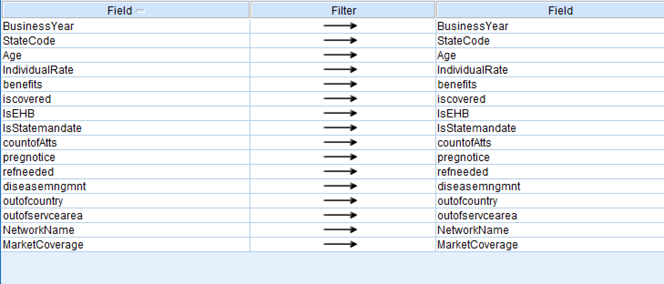

We selected Individual rate as our target variable.
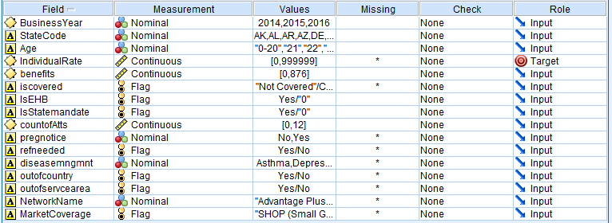

Modeling - Investigative questions
Our primary research is to determine the following:
- Which healthcare plan benefit(s) and attribute(s) that have the most impact on monthly premiums (individual rate)?
- Which states provide healthcare plans with the lowest cost and most benefits?
- Formulate a minimum of three common benefit and plan attribute profiles. K

Preliminary work round ups:
Due the large amount of data and the nature of our study, initially we believed a Neural Network would provide a model of high accuracy and relevancy. After numerating the categorical variables, the Initial trials utilizing the Neural Network proved unfruitful. Accuracy of the trails results were consistently below 25% and did not provide clear insights into the investigated.
Upon further review and deliberation, the team came to the consensus that using a clustering and classification method would provide the desired level of insight and accuracy. Clustering because of the need to group plan benefits and attributes into profiles based upon relationships to each other as well as other variables. Classification because we were pursuing the plan or attribute that had the most impact on one variable, individual rate. In addition, our large and formidable data set, was well suited for both modeling methods. KNN (K-Nearest Neighbors) and K-Means were the two modeling algorithms selected to replace These models strengths and limitations? 30/40
Evaluated Results:

K-NN results
Parameters
Partition: 60 training: 40 testing
K: Minimum of 3 : Maximum of 5
Findings
Predictor Importance – The major fields that had high importance in prediction were as follows:
High Factors - Out of service area coverage (Most Important) , Disease management, Reference needed, Pregnant Notice, IsStatemandate, IsEHB
Low Factors – Benefits, Individual Rate, Count of Attributes
Insights: Out of service area coverage unexpectedly proved to have the most impact on individual rate, not including age.

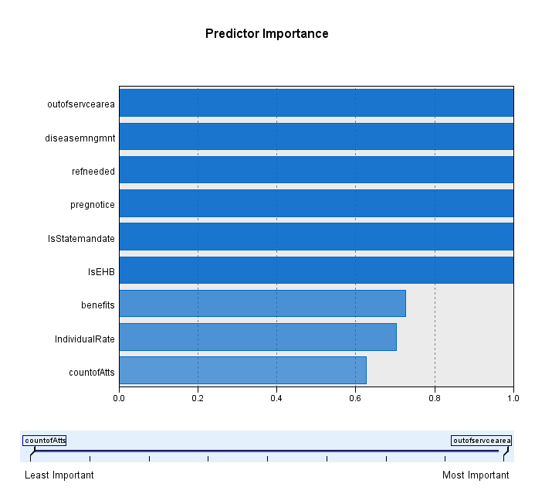

K-Means
Partition: Business Year
Maximum Iterations: 25
Encoding Value sets: 0.74611
Clusters: 5
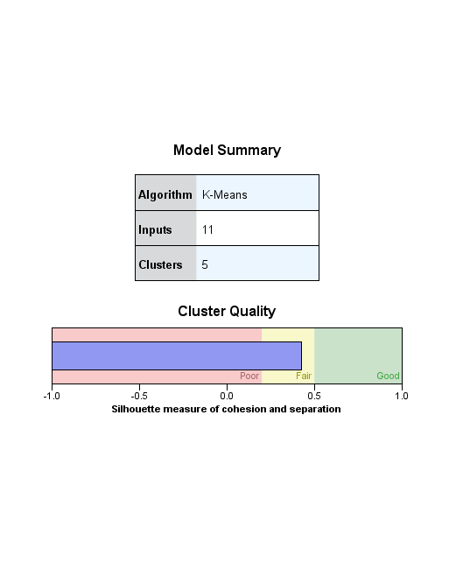

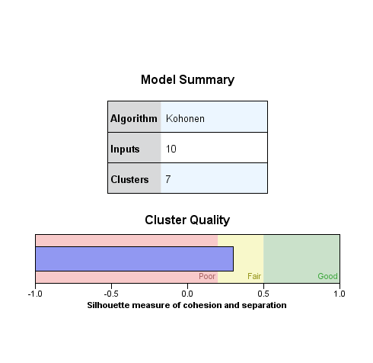
Insight: Cluster quaility was not as high as desired, however did provide satisfactory results. In addition, they were of a higher overall quality ( combination of quantity and quality) when compaired to the the TwoStep Clustering and Kohnen Clustering offered in the SPSS Modeler 18 suite. 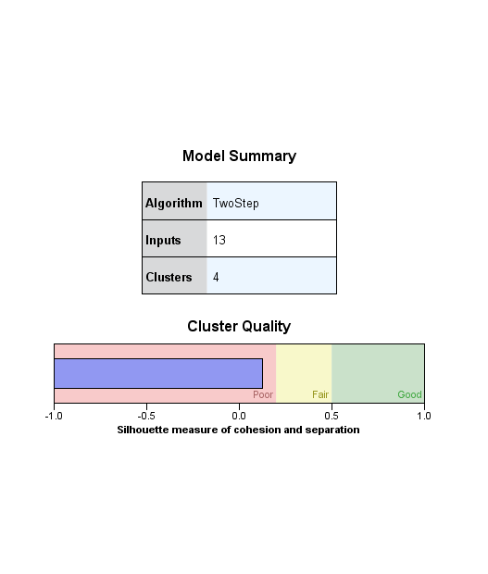

Cluster Analysis

Disease Management proved to be the most important element in the clusters, specifically the benefit related to Asthma. The following attributes were somewhat expected as they are essential or mandated indicating a government, local or federal requirement. The fourth element confirms the importance of the out of service area coverage to the individual rate.
Pruning was conducted down to three clusters however Cluster 2 remained with 0.1% or less of the records regardless on the number of clusters specified.
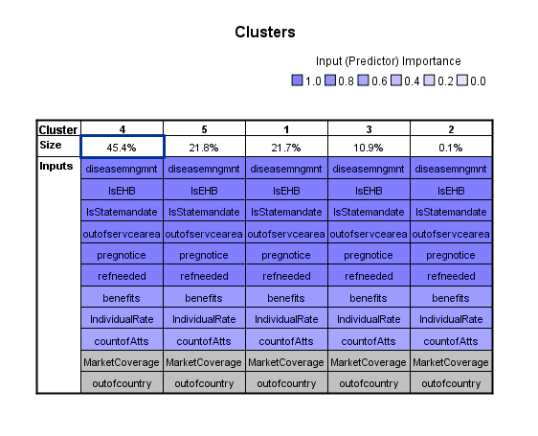
Recommendations: NEED MORE NARRATIVE BELOW
Small Business owners and business owners in general do have options in regards to minimizing their Affordable Care Act burden. Below are three options based on our findings;
Only offer employees local coverage. Out of service area coverage proved to have the biggest impact on individual rate. This reduction in cost could greatly reduce the health insurance cost for businesses of all sizes. K
Relocate to Utah, Mississippi, New Mexico, Oregon, or North Carolina. These states offer the best cost to benefit ratio for employers and individuals. K
80/90==452 FOR REPORT
Presentation 40/50 DO NOT CLUTTER WITH SENTENCES—USE KEY WORDS AND PHRASES
TOTAL=492 PTS!!

